**AERO 430 – Assignment One**



Antonio Diaz ‘22

**Due 01/27/2020**

1) Formulate the problem of heat conduction in a rod assuming convective boundary condition at x=0, following the Bradshaw Assignment 1 Report. **Everything is given to you are only asked to study it, understand and describe it in your own report.**

Bradshaw assignment 1 report gives a description of the heat transfer across a rod with different temperatures at each end. The given diagram in the report describes the positive heat flow across the rod that results from conservation of heat:



A comprehensive heat equation is then generated from three equations:

Taylors series expansion:

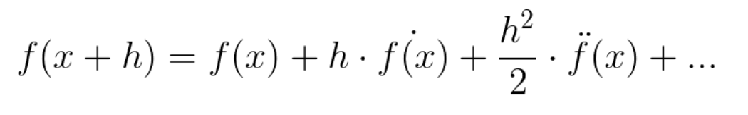

Newton law of cooling:

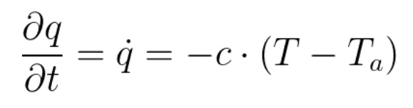

Fourier’s law of heat induction:

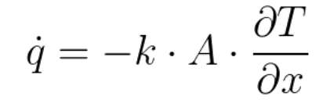

Combining these equations leads to:

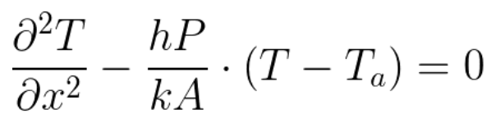

or

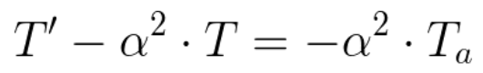

**Determine an Analytical Expression for the Exact Solution and use it to compute the Errors in all the Quantities Computed via FDM in Questions 2 & 3 below.**

The second order differential equation requires a homogenous solution, taking the form:

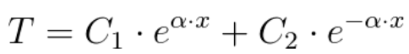

To take ambient temperature into consideration, the equation can be describe by:

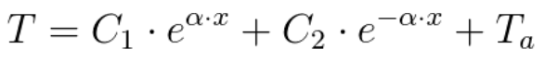

This can be rewritten as:



Solving for the coefficients can be done with linear systems of equations using T(0) = 0 and T(L) = 100:

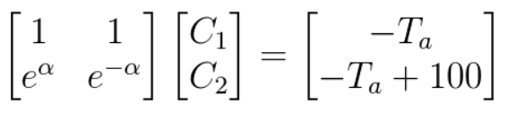

This leads to:

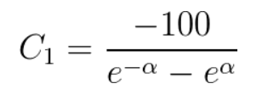

and

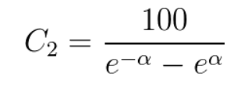

= (+)/2 and = (-+)/2

An analytical solution to the problem with varying levels of alpha for specified boundary temperatures (case 1) and specified root boundary condition with convection from free-end tip (case 2) are shown below:

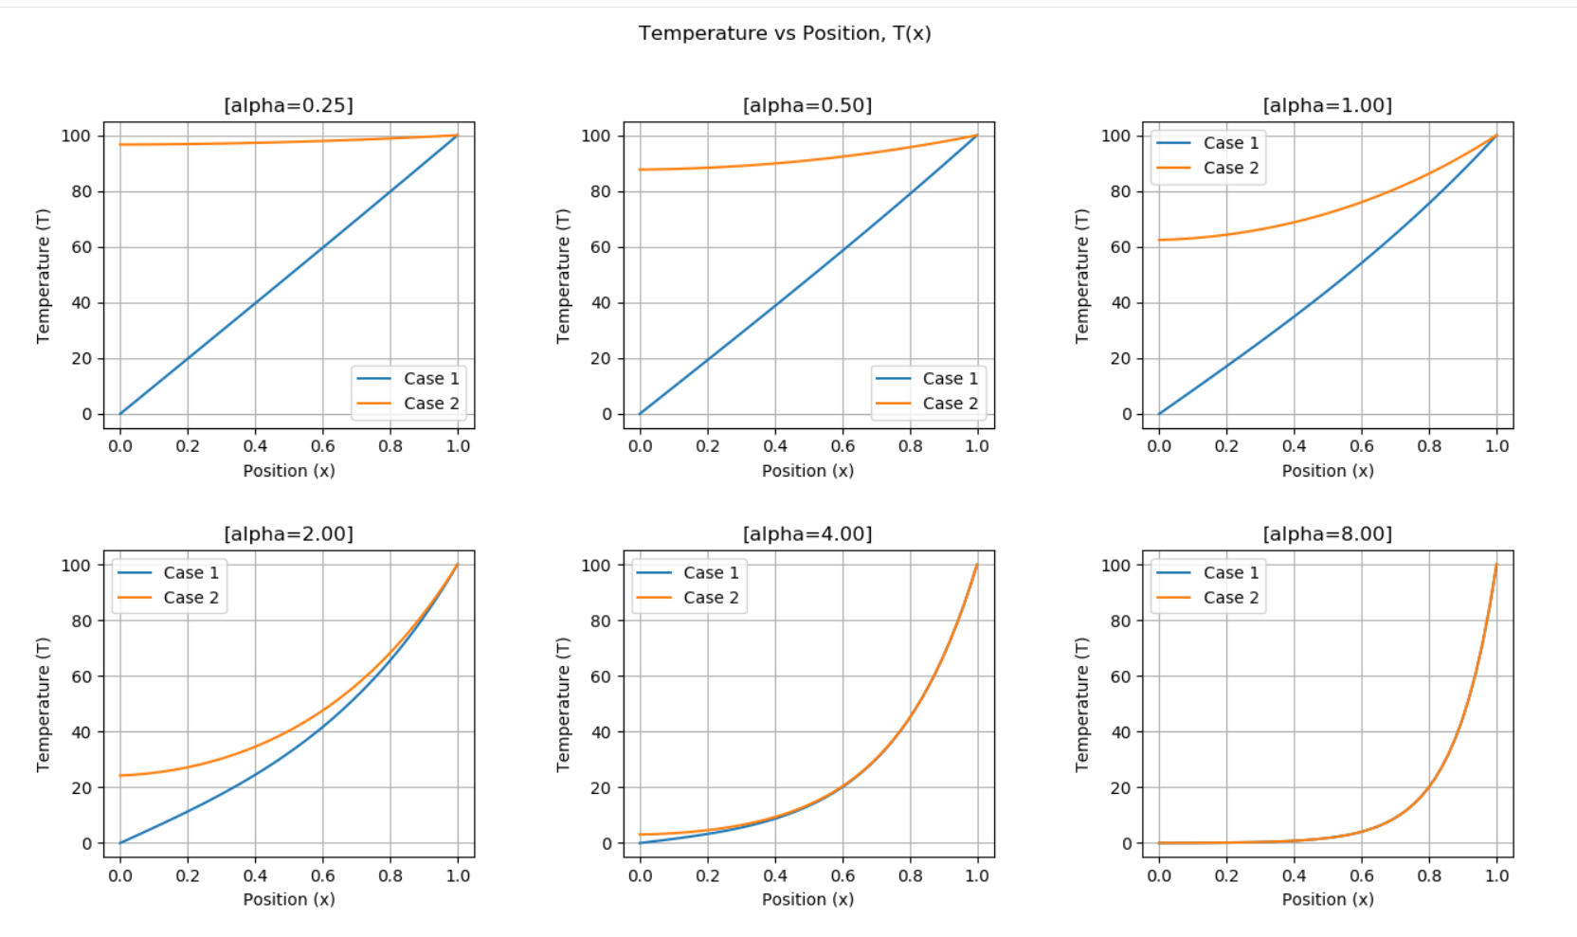

2) Formulate and solve the Finite Difference Equations. Use the Bradshaw Assignment 2 report and the code provided in that report. Are you able to reproduce the numbers given in the Tables of the report?

The finite difference equations come from Taylor series addition:



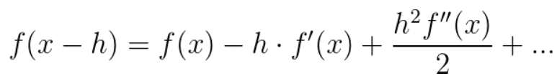

Adding both functions leads to:

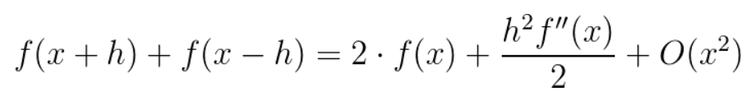

f’’(x) can then be redefined as:

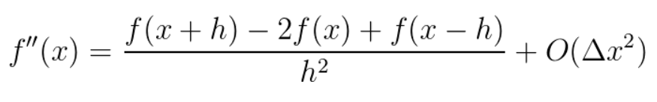

Through a similar process, f’(x) is also shown by:

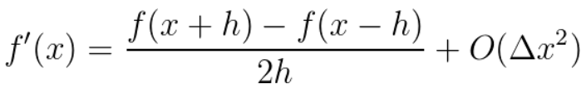

These finite difference elements can then be plugged in to 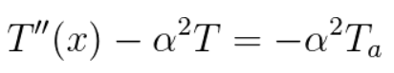:

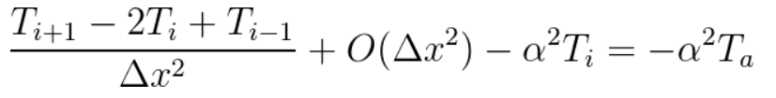

After truncation and multiplying by , the result for is given by:

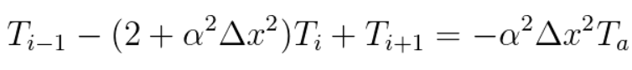

Using , the equation is written as:

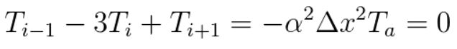

Using = 1/(), the system of equations can be written as:

x = .25cm 

x = .50cm 

x = .75cm 

The matrix form of these equations can be rewritten as:

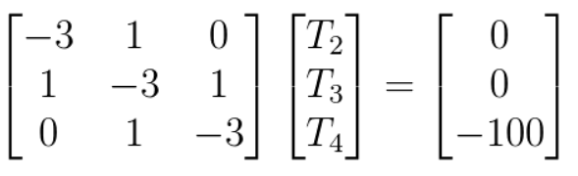

With numpy python packages, this can be programmed and leads to the same results as Bradshaw for case 1, of constrained temperature Dirichlet boundary conditions:

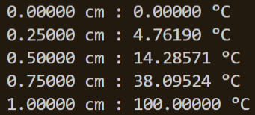

Case 2 with free, convecting tip leads to the issue of the -1 (“ghost”) index:



Using the first order taylor series shown earlier, can be shown to be:

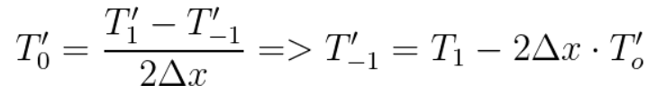

This can be replaced in our initial second order differential equation as follows:



Our boundary conditions can also help simplify this further:

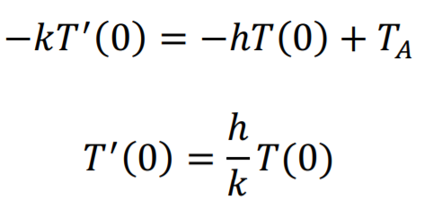

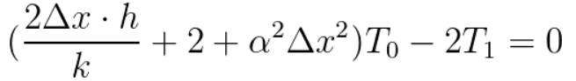

This can be replaced by another matrix:

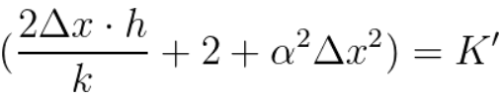

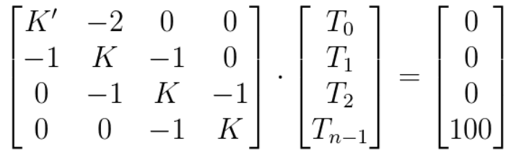

(n representing the divisions)

This system of equations had the same values as in Bradshaw’s paper shown for alpha = 4, with a deltaX of .125 cm, by my python code outputs:

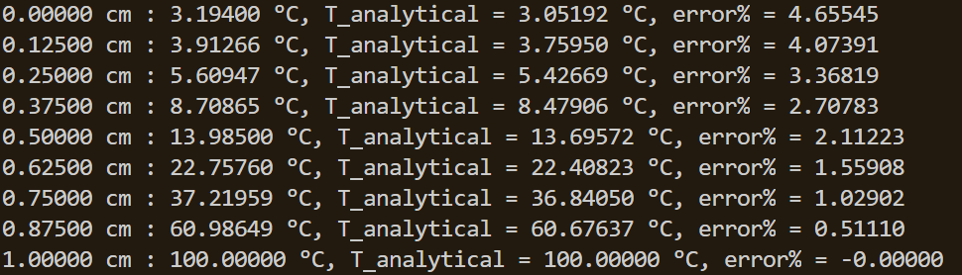

3) Compute the Heat-Loss in two ways:

1. By computing the heat entering the domain at x=L;

Heat loss entering the domain at x= L is found by using the definition of heat transfer across the bar:

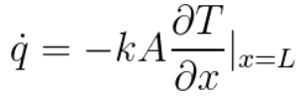

This can be approximated using Taylor series as follows:



Rearranging for T’(n) leads to

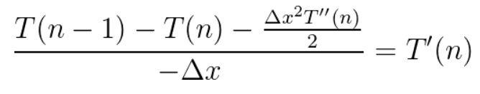

From our original second order differential equation, the following becomes true:

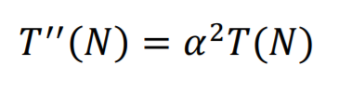

Solving for T’(n) and replacing this value in our heat loss equation leads to:

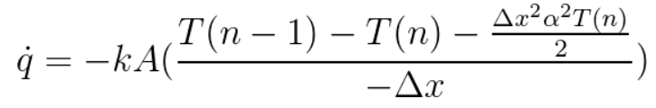

The rate of convergence between the exact solution can be defined by

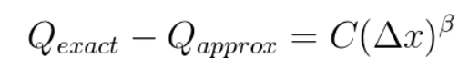

This can be rearranged with a successive approximation with:

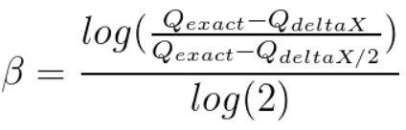

The result of using these equations in python leads to the following results the agree with Austin Bradshaw’s results:

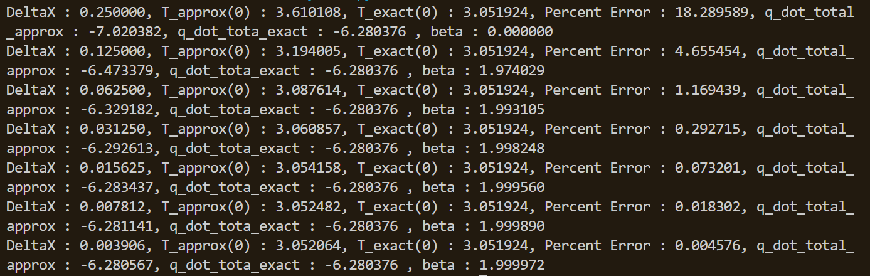

1. By computing the total heat flux exiting the domain through Newton Cooling from the lateral surface and the cross-section at x=0. Present your results in the same way as Bradshaw using Tables & Graphs and report the Convergence Rates

Total heat flux can be calculated by

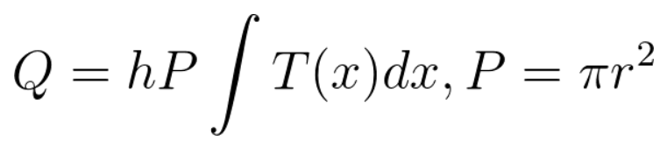

Using Simpsons rule, the total lateral heat flux can found and programmed in python. The lateral heat can also be extrapolated using Richardson extrapolation with the following relationship:

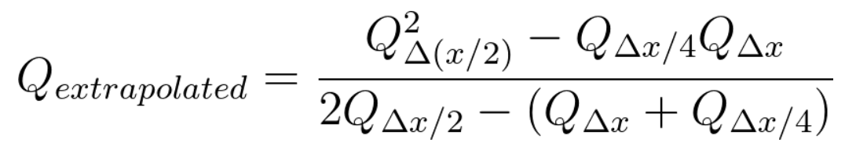

Convergence for case 2, with heat flux, extrapolated values, and Beta values are given from the code below:

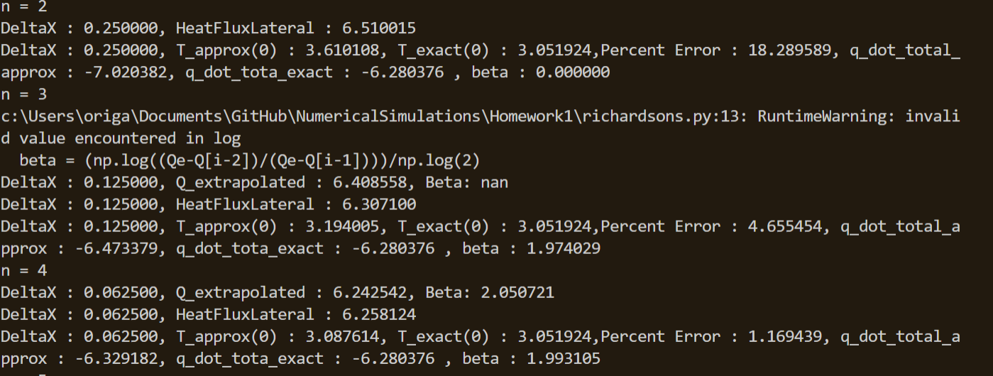

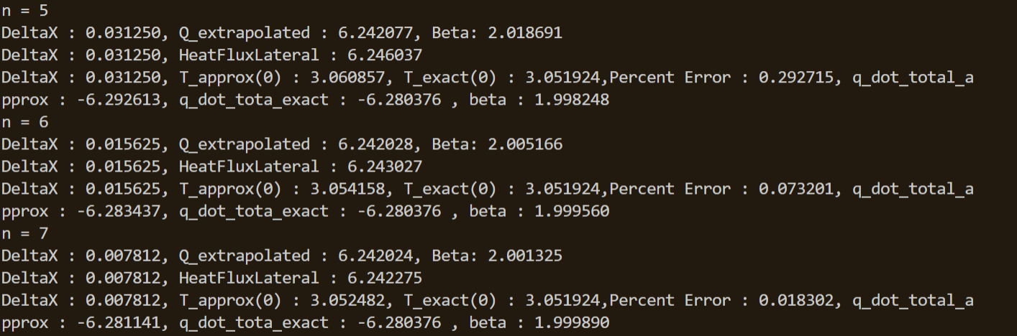

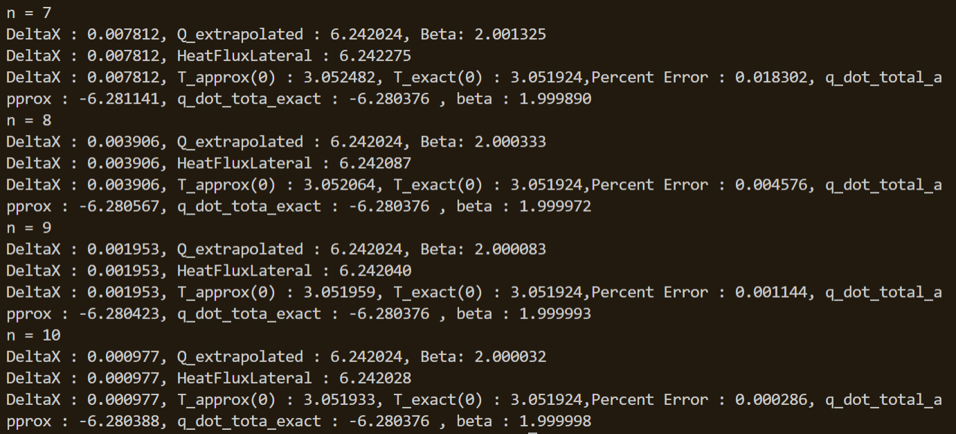

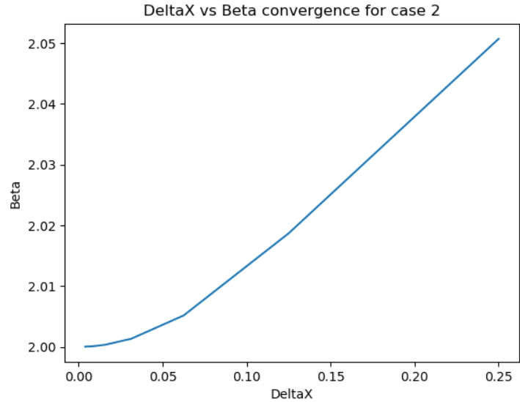

Conclusion:

Using finite difference models, the Temperature as a function of position on the heat rod can be estimated. The current models used in this homework assignment make use of second order finite difference models and lead to a converge Beta value of 2, as predicted. The code I created in Python for the class uses the same models and ideas, however it is inefficient in solving the temperatures, not using the Thomas algorithm, instead just using the numpy packages to find the inverse.

Personally, the assignment surprised my in how accurate the models are with little increase in step size, while also learning to use Richardson extrapolation to compare accuracy if an analytical model isn’t given.